1. UI is designing the buttons, text box etc web components while UX is keeping the design in a way to provide better user experience.
2. Front end developer is a person who aligns all the web components together and decides how the website will look and function.
3. Back end developer is a person who develops a system which helps to answer the client calls and provides any data from database if necessary.
4. Github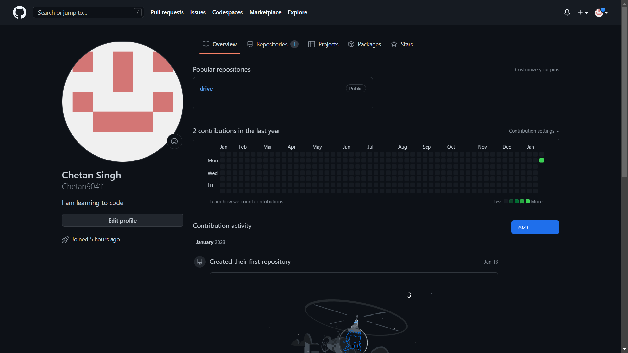

Link: <https://github.com/Chetan90411>

Linkedin



Link: <https://www.linkedin.com/in/chetan-singh-168564251/>

6. I have already written many blogs on quora so I am sharing one of my links here:<https://qr.ae/prAAEp>